**HO CHI MINH UNIVERSITY OF TECHNOLOGY**

**OFFICE FOR INTERNATIONAL STUDY PROGRAMS - OISP**

**Logic Design with HDL**

ASSIGNMENT REPORT

**DIGITAL CLOCK**

Group information:

| Class : Logic Design with HDL (Lab)  Group : 2 | Lecturer’s comment |
| --- | --- |
| Full name:   1. Nguyễn Văn Bình : 2153223 2. Lê Minh Quý : 2153758 3. Trần Hải Đăng : 2153297 4. Phạm Đức Trung : 2153928 |  |

**Introduction**

* Assignment topic: Digital clock
* Scope: Display hour/minute, alarm hour/minute and month/date on 4 7-segment leds as well as alarm signal. Moreover, it can be adjusted month, date, alarm clock and clock depending on which mode is chosen.
* This report consists of 5 sections:
* **Section 1**: Background and applications
* **Section 2**: Design
* **Section 3**: Implementation
* **Section 4**: Results
* **Section 5**: Conclusion

1. **Backgrounds and applications**

Background: this project is the combination of all of the knowledge in the theory class.

Application: It is apparent that a digital clock is an object with high application in real life. It helps us manage time better. For example:

* It helps people to be alert at a particular time in life to remind them what they need to do or something they need to remember at that time.
* It is applied into many devices such as electronic clocks, cookers, microwaves,... so these devices can self-operate automatically at the exact time.

1. **Design**

First, we need to let the second increase 1 unit every 1 Hz clock signal and make the clock run logically. Then pass it to the alarm clock to compare the real time and alarm time to determine whether to trigger the alarm signal to toggle 2 RGB leds, we can also adjust the alarm clock here. Meanwhile, the clock time is also passed to month date to make the month date module run logically. Then, we are going to display the digits on 4 leds based on which modes we choose.

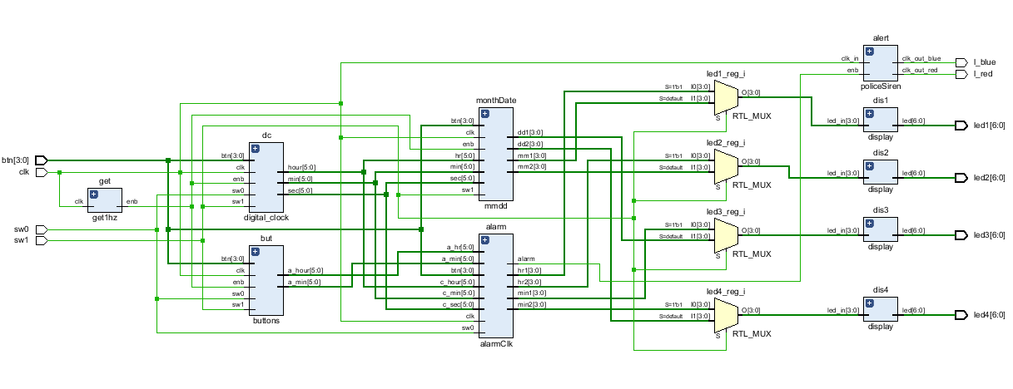

1. **Implementation**

* module combine: combine all sub-modules together and determine which signal is displayed on the leds.
* module get1hz: get 1 hz clock signal
* module buttons: adjust the alarm clock
* module edgeDetector: detect the button signal when it is pressed.
* module digital_clock: make the time run logically as well as adjust it
* module mmdd: make the date and month run logically as well as adjust month date.
* module alarmClk: compare the real time and the alarm time to trigger alarm signal. Moreover, when button 2 or 3 is pressed, leds will display the alarm clock, then it returns to real time.
* module policeSiren: when the alarm signal is triggered, led 4 and 5 will display red and blue alternatively in 1 minute.
* module display: display the digits on 7-segment leds.

1. **Result**

* Experiment setup: we need 33 wires: 32 wires connected to io gates, the left one is connected to 3V gate. Then adjust constraint file to make it matched with the code (for more details please consider our constraint file)
* Method of controlling clock:

+ sw0: if sw0 then turn on alarm mode. Otherwise, turn off alarm mode.

+ sw1: if sw1 turns on then display hour and minute. Otherwise, display month and date.

+ btn0: increase minute by 1 unit if sw1 turns on. Otherwise, increase day by 1 unit.

+ btn1: increase hour by 1 unit if sw1 turns on. Otherwise, increase month by 1 unit.

+ btn2: increase minute of the alarm by 1 unit.

+ btn3: increase hour of the alarm by 1 unit.

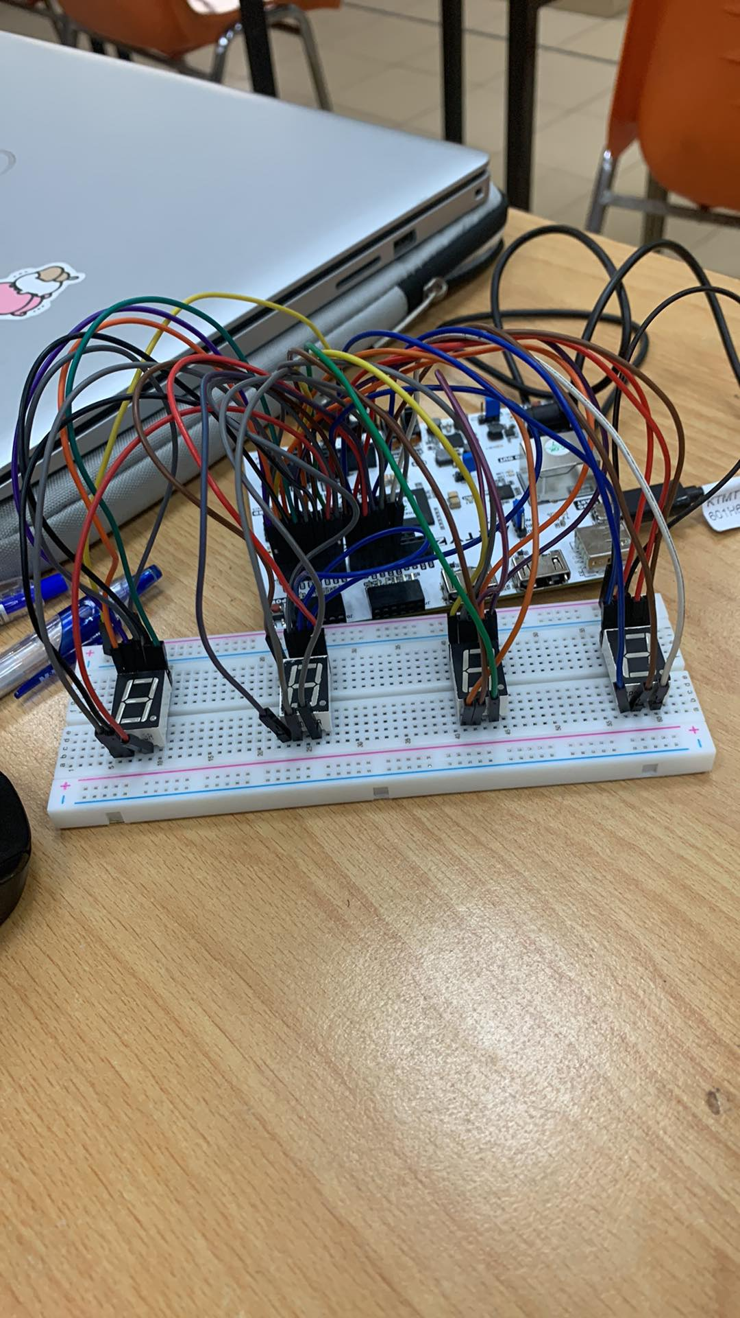

*The completed board*

* This project takes about 7 minutes to complete from synthesis to programming the device.
* Resource Utilization: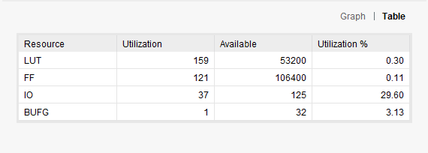

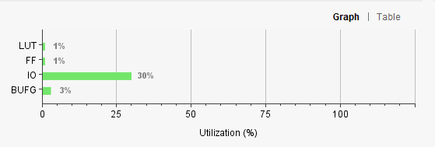

* Waveform:

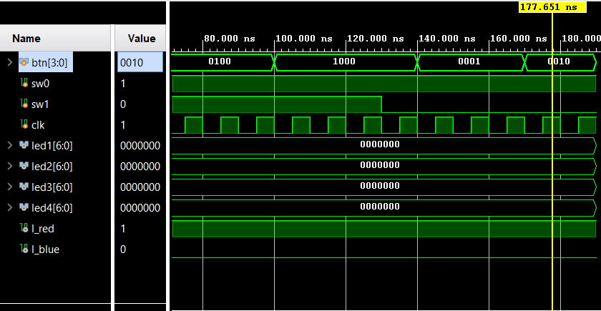

1. **Conclusion**
2. Working achievements

* The circuit displayed as expected, ensuring all the logic of the time.
* Learned a lot of new things through coding and debugging.

1. Advantages

* Have all the basic and essential features of a digital watch (display hours, minutes + alarm hour minutes + alarm + date + editing modes)
* Can run on compact, light circuit
* Exert the most of the arty-z7 20 functions

1. Disadvantages

* Lack of aesthetics: The clock does not have a led display ":" separating the hours and minutes
* The complexity of the large circuit causes a (small) delay when displaying the clock

1. Future work

* About the alarm mode: replace the RGB light blinking function with a Zynq processor core running embedded software to control sound output when alarms
* About aesthetics: Buy and install additional “:” led when displaying the led meter
* Technical: Reduce the number of modules as well as the complexity of the modules as low as possible but still ensure to retain all existing functionality

**End.**